**IN THE UPPER TRIBUNAL (LAND CHAMBER)**



**HA/32/2019**

**B E T W E E N:**

**(1) NASIM HUSSAIN**

**(2) FHCO LTD**

**(3) FARINA HUSSAIN**

**Applicants**

**AND**

**WALTHAM FOREST LBC**

**Respondent**

**ORDER**

Before the Hon. Sir David Holgate and Judge McGrath (President of the First-Tier Tribunal (Property Chamber)

**UPON** hearing Mr Jonathan Bates for the Applicants and Mr James Findlay QC and Mr Riccardo Calzavara for the Respondent

**AND UPON** the Tribunal delivering a written judgment

**IT IS ORDERED THAT**

1) The application is dismissed

2) Permission to appeal is refused

3) We refuse to stay the order in the FTT of Judge Vance dated 12 August 2019 or the appeal proceedings in the FTT. The matter is remitted to the FTT for the appeals to be determined.

**Reasons:**

1. The application submitted to us for permission to appeal is wholly misconceived.
2. Three issues were raised before us as set out in the decision at [55] to [60]. The first (and main) issue was whether s.4(1) of the 1974 Act prohibited reliance upon the *conduct* constituting the offences for which the First Applicant and her husband were convicted on guilty pleas. Our decision makes it clear by virtue of s. 4(1) that the FTT may not take into account the *convictions* themselves (which are “spent”) unless the tribunal should decide in the appeal before them that under s.7(3) they should be admitted. Paragraph 1(a) of the proposed grounds of appeal misstates the issue and our decision upon it by suggesting that we have already decided that the FTT can take into account the spent convictions. As matters currently stand, the convictions are inadmissible by virtues of s. 4(1), as we have stated. The Respondent never argued otherwise before us.
3. On the first main issue correctly stated, we did decide not to follow *YA.* We had the benefit of detailed submissions on the issue from both parties, and our decision contains a detailed analysisof the legislation and case law, explaining why *YA* was wrongly decided. The Applicants’ proposed grounds of appeal merely assert that *YA* was correctly decided and that our decision was wrong without identifying any criticism of that analysis at all. The proposed grounds do not reveal any realistic prospect of success. It is also insufficient for the Applicants merely to say that the point decided by this Tribunal is one of general importance without making any attempt to identify the alleged error or errors in its reasoning, so as to show that there is some other compelling reason for an appeal to be heard in the Court of Appeal.
4. A second issue raised before us, and in the proposed grounds of appeal, was whether the proceedings before the Respondent leading to its decisions the subject of the Applicants’ appeal to the FTT, constituted “proceedings before a judicial authority” within the meaning of s.4(6) of the 1974 Act. In our decision [109] and [136] we pointed out that this issue had no legal consequence for the determination of the Applicants’ application to strike out parts of the Respondent’ case in the FTT; the application for strike out was the only matter before us. The Applicants’ proposed grounds of appeal do not say otherwise. We did give a brief opinion on the issue raised in order to provide some assistance to local housing authorities generally ([137] to [145]). The wording of s.4(6) is clear beyond peradventure. The Applicants do not suggest that this part of our decision affected the outcome of the application to strike out (nor do they say why the reasoning was wrong) and so it would be wholly inappropriate to grant permission to appeal on this aspect.
5. The third issue before us related to the potential application of s.7(3) of the 1974 Act to override s.4(1) in the appeal before the FTT (in relation to convictions and sentences, and possibly also conduct). The Applicants advance no grounds of appeal in relation to this part of the decision ([146] to [170]). In substance we accepted the Applicants’ submissions on the test to be applied under s.7(3). We then decided that we should not accede to the Applicants’ argument that strike out was justified because the Respondent could not reasonably succeed in relying on s.7(3) ([168] to [169]). The proposed grounds of appeal make no criticism of this part of our decision. In this part of their argument, the Applicants accepted that if their application to strike out should fail, the case would be remitted to the FTT (see [48]). At all events, there is no suggestion that our decision on the s.7(3) issue can give rise to any proper ground of appeal.
6. For these reasons we refuse the application for permission to appeal.
7. In the circumstances, we consider it inappropriate to approve that part of the draft order which would further stay the order of Judge Vance dated 12 August 2019. We refuse to stay that order pending any application to the Court of Appeal for permission to appeal, or otherwise. The matter came before us solely in relation to the Applicants’ application to strike out part of the Respondent’s case. That application has wholly failed. The appeals before the FTT remain to be determined as a whole and it is firmly in the public interest that the status of the Respondent’s licensing decisions be resolved. There is no merit in the proposed grounds of appeal and no justification therefore for us to interfere with the FTT continuing to proceed towards the determination of the appeals. In so far as the Applicants are successful before the FTT, there will be no need for any further appeal. In so far as the Applicants are unsuccessful and have proper grounds of appeal to raise, they can be considered I any appeal as a whole. We also note that if the FTT should decide to admit material under s.7(3) applying the test we have set out, and if that decision should be incapable of challenge, then the grounds of appeal currently advanced would very likely be academic so far as the outcome of the Applicants’ appeals against the Respondent’s decisions are concerned.

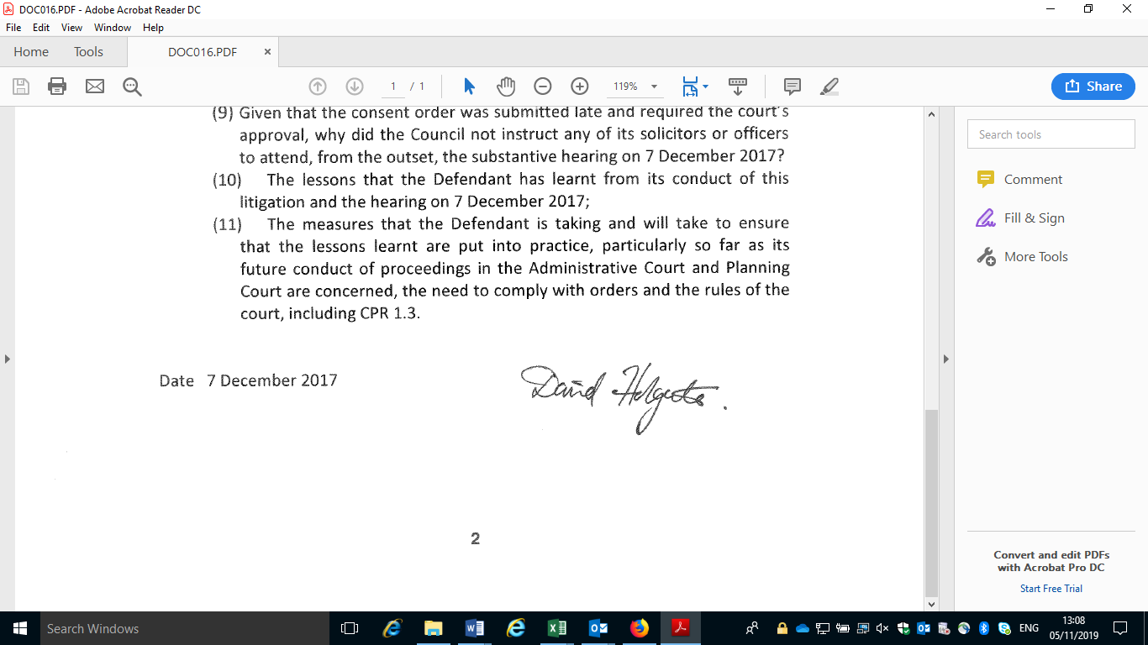The Hon. Sir David Holgate

Judge Siobhan McGrath

5 November 2019